EET 110 TEST I FALL 2019

**NAME:**

1. (6 P) How much energy in Joules does a 20 V battery has if it contains 5 C of charges?
2. (6 P) A car electric heater consumes 120W of power and works with 12 V. How much current does it draw from the source?
3. (18 P) Complete the table below by determining the resistor values and tolerances from the color codes and by applying the color-codes for the values and tolerances of the given resistors.

|  |  |  |  |  |  |
| --- | --- | --- | --- | --- | --- |
| BANDA | BAND B | BAND C | BAND D | VALUE | TOLERANCE |
| BROWN | YELLOW | BROWN | NONE |  |  |
| RED | ORANGE | BLACK | GOLD |  |  |
| GREEN | BROWN | GOLD | SILVER |  |  |
|  |  |  |  | 3.0 MΩ | 10% |
|  |  |  |  | 2.5 Ω | 20% |
|  |  |  |  | 330 Ω | 5% |

1. (5 P) A 10KΩ resistor has a tolerance of 10%. What is the range of resistance value?
2. (15 P) Calculate  in the circuit below.
3. 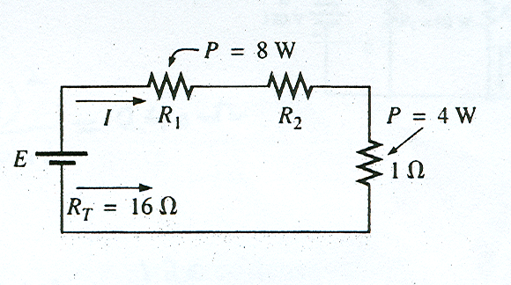(25 P) Find R1, R2, I, and E in the figure below
4. (25 P)The total power dissipated in the circuit of Figure below is 60 Watts. Find
5. The current in the circuit
6. The resistance of R2
7. 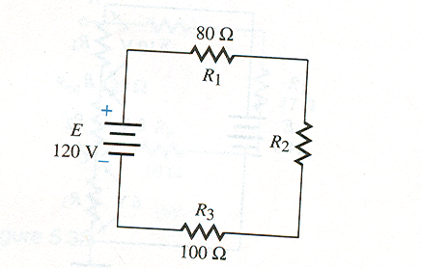The voltage across each resistor

Hint: Find current I in the circuit using total power delivered by 120V source.

1. (10P) An electric pencil sharpener rated 240mW, 6V is connected to a 9-V battery as shown in the Figure below. Calculate the value of the series resistor Rx needed to power the sharpener. Hint: the pencil sharpener will be damaged if consumes more than 240mW.

